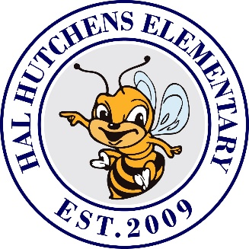

**Hutchens Elementary**

**School Supply List**

**2022 – 2023**

|  |  |  |  |  |  |
| --- | --- | --- | --- | --- | --- |
| **Kindergarten** | **1st Grade** | **2nd Grade** | **3rd Grade** | **4th Grade** | **5th Grade** |
| * 24 ct. Crayons * Tissues * Pencil Box * Scissors * Glue sticks * (2) three-pronged poly folder * Disinfecting Wipes * Hand Sanitizer (unscented) * Baby Wipes     **Optional***:*  Ziplock bags (gallon, sandwich, and snack size)  Headphones (Over the head/ No earbuds) | * Tissues * 24 Pencils (Ticonderoga Preferred) * 2 glue sticks * 2 Boxes of 24 Crayons * Disinfecting Wipes * Baby Wipes * Sandwich Bags * Hand Sanitizer * Gallon Bags * 1 Red Poly 3 Prong Folder * 1 Blue Poly 3 Prong Folder * Pencil Box or zipper pouch * Erasers   **Optional:**  Headphones/Earbuds | * Crayons * Tissues * Pencils * Pencil box * Scissors * Glue sticks * 4- Composition Notebooks * 1 Spiral notebook * Markers (washable) * Disinfectant Wipes * Baby Wipes * Baggies (all sizes) | * Crayons * Tissues * Ruler * Pencils * Pencil box or zipper case * Scissors * Glue sticks * Colored pencils * Notebook paper   (**wide-ruled**)   * 3 Composition Notebooks * 2 poly folders * Dry Erase Markers * Hand Sanitizer | * Crayons/colored pencils * Scissors * Glue Sticks * Tissues * Pencils * Pencil box or Zipper case * 3 pks of notebook paper   (wide-ruled)   * 5 Composition Notebooks * 1 (1 inch) 3 ring Binder * 2 pocket folders   **Optional:**  Ear Buds  Baby Wipes  Hand Sanitizer  Ziploc Bags (gallon and sandwich) | * Crayons * Tissues * Pencils * Zipper case * Notebook paper -   (wide-ruled)   * Colored pencils * 5 Composition Notebooks * Glue sticks * Scissors * Colored Pencils * Cap Erasers   **Optional:**  Ear Buds  Clorox Wipes  Hand Sanitizer  Ziploc Bags (gallon and sandwich) |